Lab 1 Deliverables (as of 11 Feb 2016)

Contents

Functional & Non-functional Requirements 2

Functional Requirements 2

Non-Functional Requirements 2

Data Dictionary 3

Initial Use-Case Model 5

Initial Use Case Diagram 5

Use Case Description 6

UI Mockups 7

Landing Page 7

Results Page 8

Results Page (Compare List) 9

Comparison Page 10

# Functional & Non-functional Requirements

## Functional Requirements

1. The application must allow the users to search for apartments to compare
   1. The maximum number of apartments to be compared is 3
   2. The minimum number of apartments to be compared is 1
   3. The filters for the users to search for apartments are Budget Range, Region, Distance which is referred to the radius from pin, and the number of rooms
2. The application must have categories for the users to compare between apartments
   1. The comparison categories are Amenities, MRT Station, Schools, Shopping Mall, Park, Resale Price, the available bus-stops available within 1 kilometre radius and Lease Commencement Date
   2. The information of the categories for the apartment must be listed in tabular format

## Non-Functional Requirements

1. The users are able to reflect any errors encountered to the developers through a feedback form
2. The feedback form must contain the headings for name, e-mail and the feedback content
3. After the users refresh the application, the application must be available for usage within 1 minute
4. The application must be able to respond to the user’s request within 10 seconds
5. After 10 seconds the system must display an error message to the user and prompt them to retry.
6. The application must be able to reflect any updates in the data used for the application.
7. The application must be able to run on Google Chrome & Firefox browsers.
8. Distances shown or input must be in Kilometres.
9. Prices shown or input must be in Dollars
10. If the system encounters any error there must be an error message.

# Data Dictionary

|  |  |  |
| --- | --- | --- |
| **Name** | **Description** | **Type** |
| Apartment | Represents a single HDB flat. Limited to data of flats that can be found in the dataset from the data.gov.sg website. | Class |
| Filter | Filter refers to the search criteria that the user can set on the UI whilst searching for apartments. | Terminology |
| Budget Range | The budget range refers to the intended amount of money (defined with a minimum and maximum) the user is willing to spend on the apartment. | Attribute |
| Region | Region refers to the general region limited to Singapore geography. E.g. North, South, East & West. It is an attribute of an apartment. | Attribute |
| Distance (Filter) | The distance associated with the filters is the radius measured in Kilometres around the pin on the interactive map in the UI. | Attribute |
| Pin | Pin refers to the all drag-able pin-icons on the interactive map in the application. | Terminology |
| Amenities | The amenities is a collection of the following buildings/facilities:   * MRT Station * School * Shopping Mall * Park * Bus-stops | Terminology |
| Resale Price | The resale price refers to the Resale Price of an apartment that is retrieved from the dataset provided by data.gov.sg. It is considered to be an attribute of an apartment. | Attribute |
| Lease Commencement Date | The lease commencement date is the start date of the apartment’s lease. The duration of the lease is 99 years and when the time is up, the apartment is confiscated by the government.  It is considered to be an attribute of an apartment. | Attribute |
| Comparison Categories | Comparison categories is the collection of attributes/fields that is displayed during the comparison stage of apartments. The comparison categories are:   * Apartment attributes * Amenities | Terminology |
| Data | Data refers to any data obtained from external dataset such as:   * data.gov.sg * Google Maps | Terminology |
| User | The user is defined generally as the end-user of the application. | Actor |
| Developer | The developer is defined as the person providing technical support. | Actor |
| Feedback Form | Feedback form at all times refers to the form filled up by the User to report technical errors. | Terminology |

# Initial Use-Case Model

## Initial Use Case Diagram

C:\Users\RDR\Desktop\CZ2006 Repo\lab1\UseCase.png

## Use Case Description

|  |  |
| --- | --- |
| **Use Case** | Compare Apartments using Resale Price/Location of nearby amenities |
| **Actors** | User and System |
| **Entry Conditions** | 1. User has 1 to 3 apartments to compare |
| **Exit Conditions** | 1. User is shown the  * Price * Number of rooms * Unit number of selected apartments  1. User is shown the  * Price * Number of rooms * Unit number of selected apartments * Location of their respective amenities  1. User receives an error message explaining why the screens in condition 1 & 2 cannot be displayed. |

**Flow of events**

1. User enter address into the search bar.
2. App suggests apartments based on user input sorted according to relevance, apartments listed will display price, room type, and unit number.
3. User selects from listed suggestions and adds it as one of the properties to be compared
4. Systems displays price, room type, unit number of the selected property in a table.
5. System prompts user to enter another postal code/area/postal code. This step is optional for the user and repeats until user has entered all his apartments or 3 apartments (max).
6. Each time an apartment is entered, the table is tabulated to show all entered apartments in side-by-side comparison. The default criteria are price, room type and unit number.
7. User is shown a list of optional criteria to add (MRT STATION, BUS STATION, SCHOOL, and SHOPPING MALL) with a checkbox for each criteria.
8. After user select one or more optional criteria, he clicks on compares.
9. The comparison table is reloaded to display the additional criteria that user has selected.
10. The comparison table is reloaded to display the amenities and their respective distance for each optional criteria selected along with their distances.
11. User can go back to select a different set of additional amenity criteria to compare or EXIT.

# UI Mockups

## Landing Page

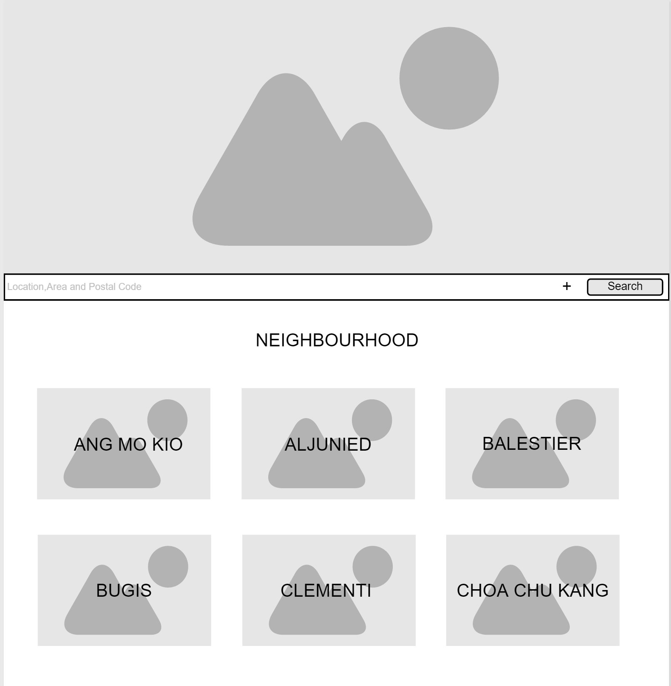

## Results Page

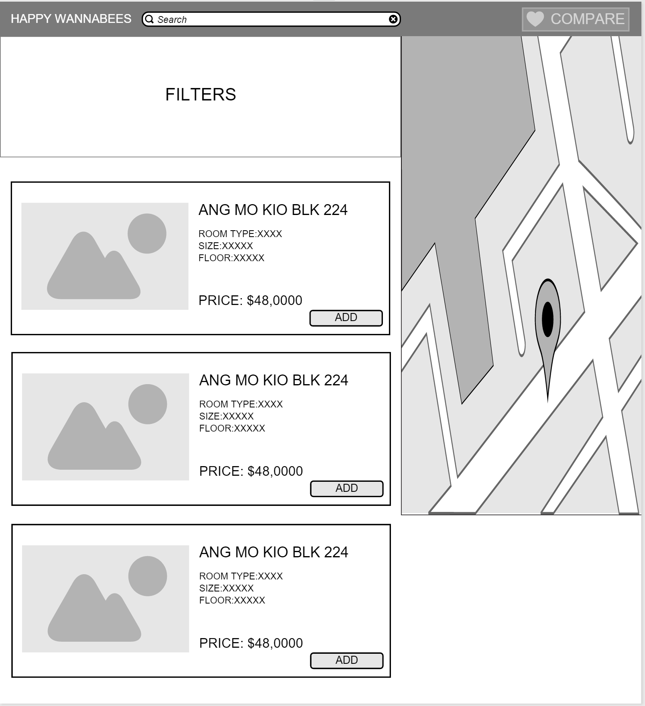

## Results Page (Compare List)

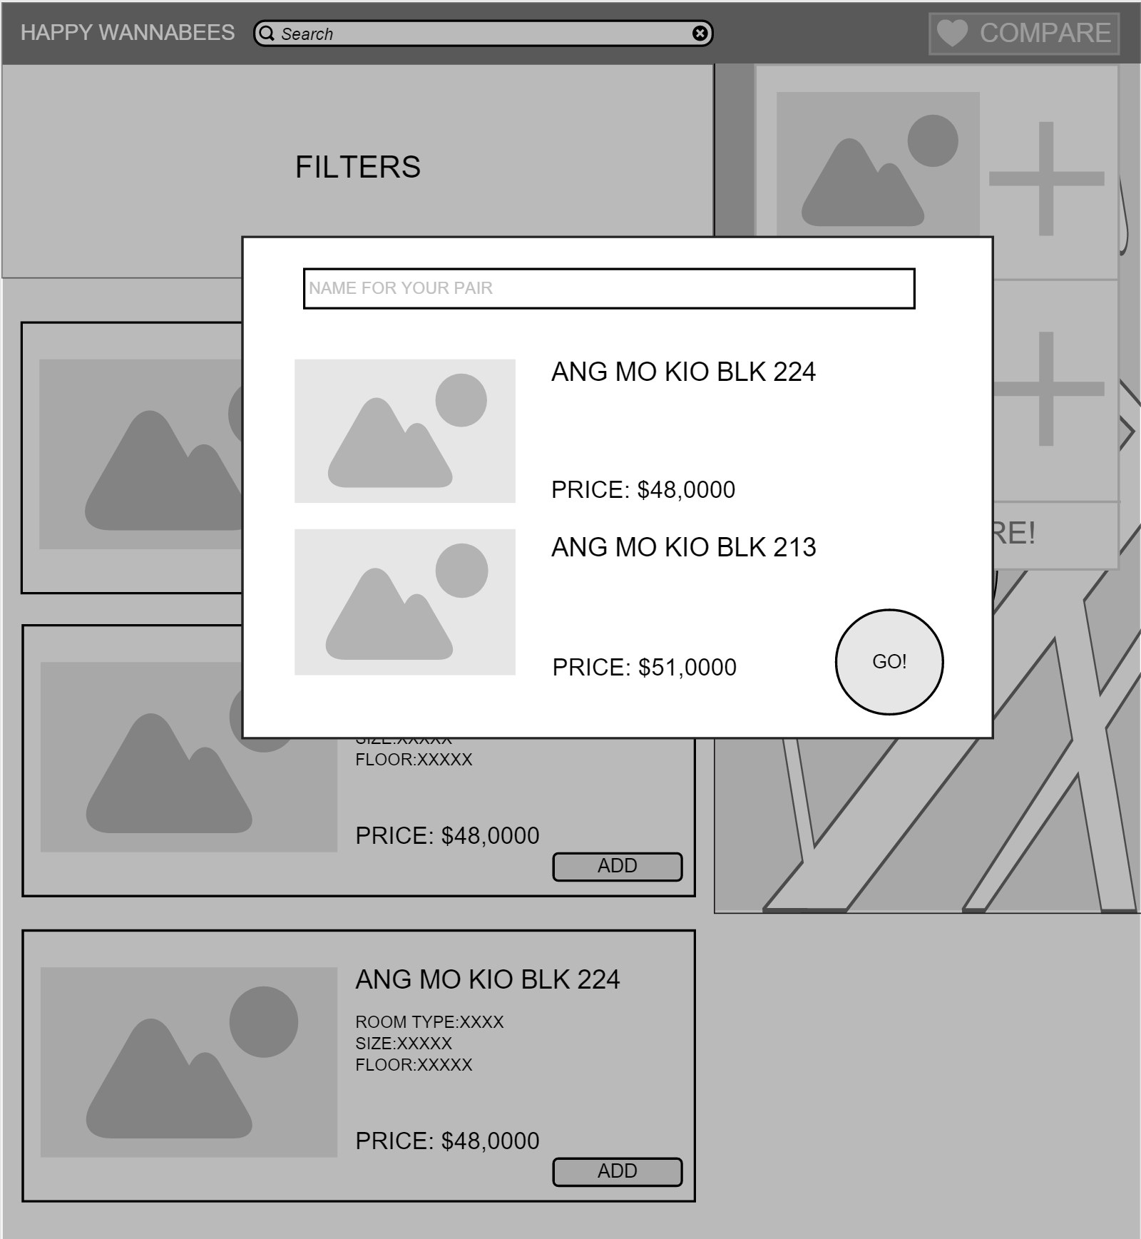

## Comparison Page

